Software Architecture
1.Architecture Overview
EduHub will follow the Clean Architecture approach to organize the backend application into independent layers. This architecture separates the core business logic from technical details such as database access, external services, and API communication.
The main goal is to make the system easier to maintain, test, and extend. Each layer has a specific responsibility, and dependencies are directed toward the inner layers. This ensures that business rules remain independent of external technologies and frameworks.
The backend will be developed as a single ASP.NET Core Web API application, while the frontend will remain a separate application that communicates with the backend through RESTful APIs.
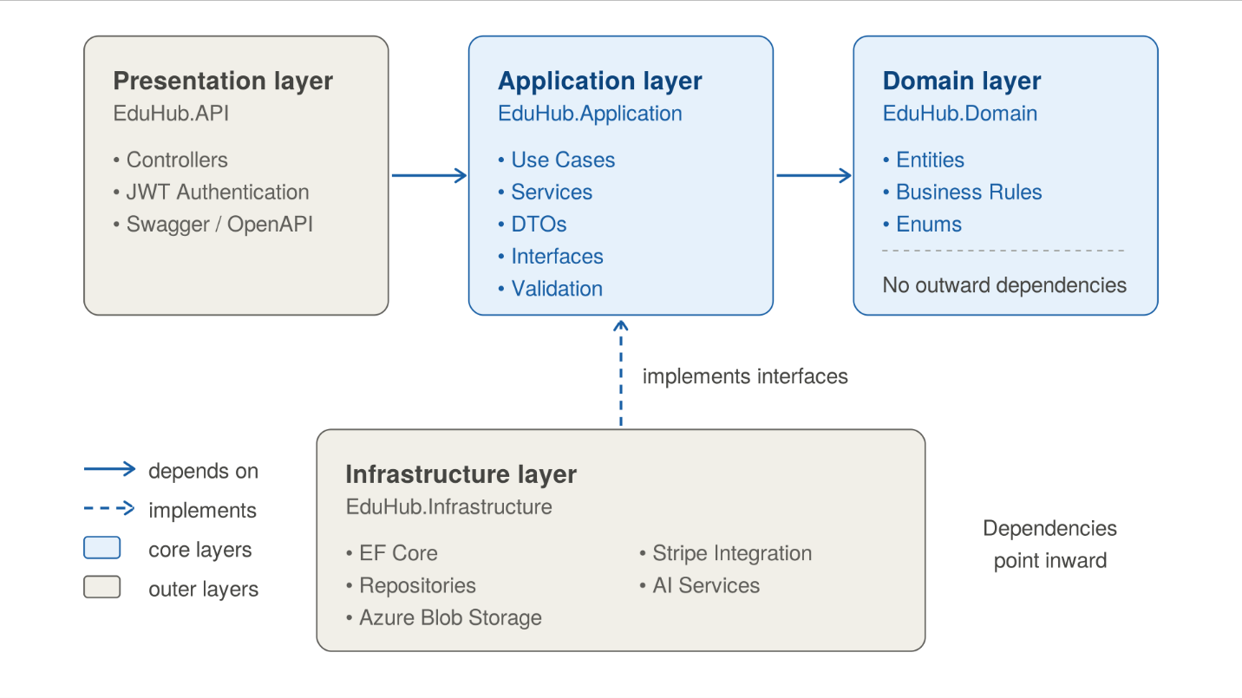
Figure: Clean Architecture Overview of EduHub.
2.Architecture Layers
The backend system is divided into four main layers:
2.1 Domain Layer (EduHub.Domain)
The Domain Layer represents the core of the application. It contains the main business entities, enums, and business rules that define how the platform works.
It includes entities such as User, Course, Section, Lesson, Enrollment, Quiz, Payment, and Certificate. This layer does not depend on databases, frameworks, or external services.
2.2 Application Layer (EduHub.Application)
The Application Layer contains the application's use cases and business operations. It coordinates the activities required to perform tasks such as creating courses, enrolling students, tracking learning progress, and generating certificates.
It also contains DTOs, service interfaces, validation rules, and abstractions for external operations. This layer defines what the application needs without depending on how those operations are implemented.
2.3 Infrastructure Layer (EduHub.Infrastructure)
The Infrastructure Layer provides the technical implementations required by the Application Layer. It handles database operations using Entity Framework Core and integrates with external services.
Examples include database access, Azure Blob Storage for course videos, Stripe for payments, AI provider integrations, and PDF certificate generation.
2.4 API Layer (EduHub.API)
The API Layer acts as the entry point for frontend requests. It contains controllers and HTTP-related components that receive requests, validate incoming data, and return appropriate responses.
It also handles authentication, authorization, middleware, Swagger documentation, and dependency injection configuration. Controllers communicate with the Application Layer instead of directly accessing the database.
3. Dependency Flow
Clean Architecture follows the Dependency Rule, which means that dependencies must point toward the inner layers.
- The Domain Layer does not depend on any other project layer.
- The Application Layer depends on the Domain Layer.
- The Infrastructure Layer implements interfaces defined by the Application Layer.
- The API Layer communicates with the Application Layer and configures the required Infrastructure implementations.
This structure keeps the business logic independent and allows technical components to be changed without significantly affecting the core application.
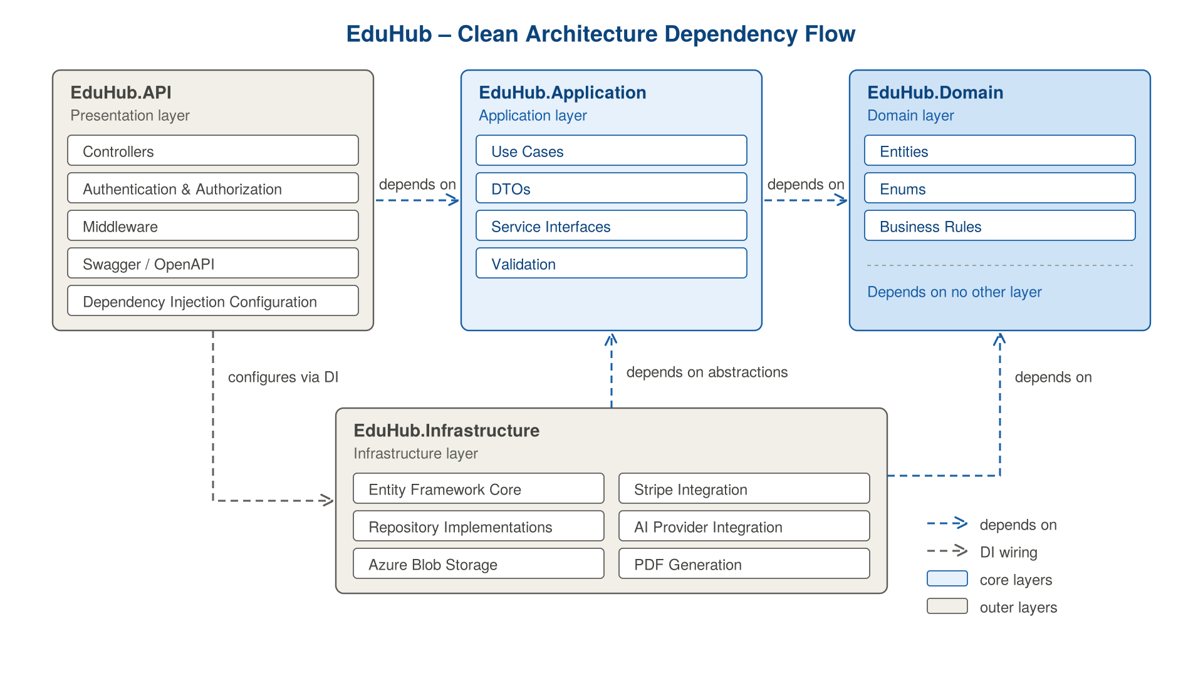
Figure 2: Dependency Flow Between EduHub Layers.
4. System Request Flow
When a user performs an action through the frontend, the request is sent to the backend through a REST API endpoint.
The API Layer receives the request and forwards it to the appropriate Application use case. The Application Layer executes the required operation using the Domain rules and the interfaces it depends on. When data access or an external operation is required, the Infrastructure Layer provides the implementation.
Finally, the result returns through the Application and API layers as an HTTP response to the frontend.
This flow keeps controllers focused on handling HTTP communication while application operations and technical implementations remain separated.
5. Technology Stack
The following technologies and services are planned for the development and deployment of EduHub.
Component | Technology / Description
Backend | ASP.NET Core Web API
Architecture | Clean Architecture
ORM | Entity Framework Core
Frontend | Standalone Web Application
Database | SQL Server
Authentication | JWT-based Authentication and Role-Based Authorization
API Documentation | Swagger / OpenAPI
Cloud Hosting | Microsoft Azure App Service
Video Storage | Azure Blob Storage
Payment Processing | Stripe
AI Integration | External AI Provider
Certificate Generation | PDF Generation Library
The final database engine, frontend framework, AI provider, and PDF generation library will be selected during implementation.
5.1 Deployment Architecture
EduHub will be deployed using Microsoft Azure App Service to host the backend Web API. The frontend will communicate with the backend through secure HTTPS requests.
The application will use a database for storing platform information, while Azure Blob Storage will be responsible for storing course video files. Stripe will handle payment processing, and an external AI provider will support the platform's AI-powered features.
Stripe will send payment confirmation events to the backend through webhooks. The backend will verify successful payments before granting course enrollment.
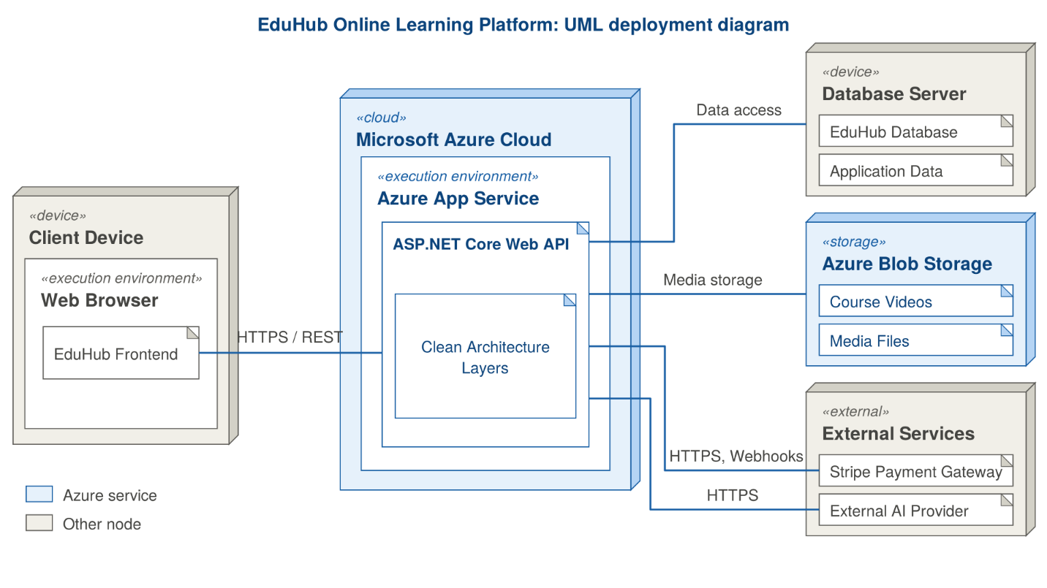
Figure 3: EduHub Deployment Architecture.
5.2 Component Architecture
The Component Diagram describes the main software components and how they interact with each other.
The frontend communicates with the API through HTTP requests. The API forwards requests to the Application Layer, which coordinates the platform's main use cases. The Domain Layer contains the core business entities and rules, while the Infrastructure Layer provides database access and integrations with external services.
External components include Azure Blob Storage for video files, Stripe for payment processing, and the AI Provider for intelligent learning and support features.
This diagram provides a high-level view of the system's internal structure and the relationships between its components.
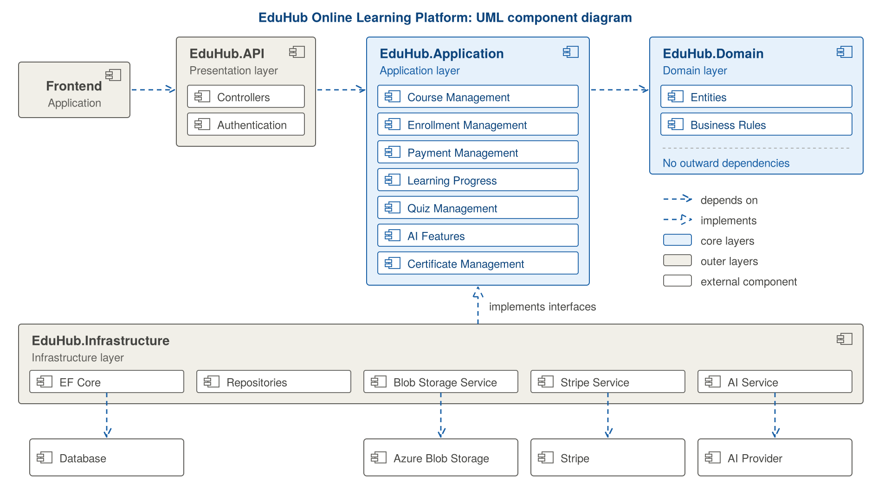
Figure 4: EduHub Component Architecture.
6. Additional Deliverables
6.1 API Documentation
6.1.1 Overview
EduHub will provide RESTful APIs using ASP.NET Core Web API to allow communication between the frontend application and the backend system.
The API will handle user authentication, course management, student enrollment, payments, learning progress, quizzes, certificates, notifications, and administrative operations.
All API endpoints will follow consistent HTTP methods, request formats, response structures, and appropriate HTTP status codes.
6.1.2 API Documentation Tool
Swagger / OpenAPI will be used to document and test the available API endpoints.
The documentation will provide:
- Endpoint URLs and supported HTTP methods.
- Request parameters and required input fields.
- Request body and response examples.
- Authentication and authorization requirements.
- Expected HTTP status codes and error responses.
Protected endpoints will support JWT Bearer Authentication. Users will access endpoints according to their assigned roles: Student, Instructor, or Admin.
6.1.3 API Base URL
The API will use the following base URL during local development:
https://localhost:{port}/api
The production base URL will be configured after deployment.
6.1.4 API Endpoint Overview
The following table describes the main API endpoint groups planned for EduHub.
Module | HTTP Method | Endpoint | Description
Authentication | POST | /api/auth/register | Register a new account
Authentication | POST | /api/auth/login | Authenticate a user
Authentication | GET | /api/auth/profile | Retrieve the current user's profile
Courses | GET | /api/courses | Retrieve published courses
Courses | GET | /api/courses/{id} | Retrieve course details
Courses | POST | /api/courses | Create a new course
Courses | PUT | /api/courses/{id} | Update a course
Courses | DELETE | /api/courses/{id} | Delete a course
Enrollment | POST | /api/enrollments | Enroll in a free course
Enrollment | GET | /api/enrollments/my-courses | Retrieve enrolled courses
Payments | POST | /api/payments/checkout | Create a Stripe checkout session
Payments | POST | /api/payments/webhook | Receive Stripe payment events
Lessons | GET | /api/lessons/{id} | Retrieve lesson details
Lessons | POST | /api/lessons/{id}/complete | Mark a lesson as completed
Videos | POST | /api/videos/upload | Upload a course video
Quizzes | GET | /api/courses/{id}/quizzes | Retrieve course quizzes
Quizzes | POST | /api/quizzes/{id}/submit | Submit quiz answers
Reviews | POST | /api/courses/{id}/reviews | Submit a course review
Certificates | GET | /api/certificates/my-certificates | Retrieve student certificates
Certificates | GET | /api/certificates/verify/{code} | Verify a certificate publicly
Notifications | GET | /api/notifications | Retrieve user notifications
AI Assistant | POST | /api/ai/learning-assistant | Ask a question about course content
AI Assistant | POST | /api/ai/summarize/{lessonId} | Generate a lesson summary
Admin | GET | /api/admin/users | Retrieve platform users
Admin | PUT | /api/admin/courses/{id}/approve | Approve a submitted course
Admin | PUT | /api/admin/courses/{id}/reject | Reject a submitted course
Analytics | GET | /api/analytics/dashboard | Retrieve analytics information
Note: These endpoints represent the proposed API structure. Final routes, request models, and response models will be confirmed during implementation.
6.1.5 Authentication and Authorization
EduHub will use JWT Bearer Authentication to protect restricted API endpoints.
After successful login, the API will return an access token that the frontend will include in subsequent requests using the Authorization header.
Example:
Authorization: Bearer {access_token}
Role-based authorization will control access to protected operations:
- Student: Browse courses, enroll, access lessons, complete quizzes, and view certificates.
- Instructor: Create and manage owned courses, upload videos, manage quizzes, and view course analytics.
- Admin: Manage users, approve courses, configure categories, and access platform-wide analytics.
Public endpoints, such as course browsing and certificate verification, will not require authentication.
6.1.6 HTTP Status Codes
The API will use standard HTTP status codes to communicate the result of each request.
Status Code | Meaning | Example
200 | OK | Data retrieved successfully
201 | Created | Course created successfully
204 | No Content | Resource deleted successfully
400 | Bad Request | Invalid request data
401 | Unauthorized | Missing or invalid token
403 | Forbidden | User does not have permission
404 | Not Found | Requested resource does not exist
409 | Conflict | Duplicate enrollment or conflicting operation
500 | Internal Server Error | Unexpected server error
6.1.7 Example API Request and Response
Example: User Login
Endpoint:
POST /api/auth/login
Request Body:
{
"email": "student@example.com",
"password": "YourPassword123"
}
Successful Response (200 OK):
{
"accessToken": "JWT_ACCESS_TOKEN",
"tokenType": "Bearer",
"expiresIn": 3600,
"user": {
"id": 1,
"name": "Student Name",
"email": "student@example.com",
"role": "Student"
}
}
The returned access token will be used to authenticate subsequent requests to protected endpoints.
6.1.8 API Security
All API communication in production will use HTTPS. Protected endpoints will validate JWT tokens and enforce role-based authorization.
Course ownership and student enrollment will also be checked before allowing access to restricted operations and paid course content.
Payment enrollment will only be confirmed after successful payment verification through Stripe webhooks.
6.2 Testing and Validation
Testing and validation will be performed throughout the development process to ensure that EduHub meets its functional and non-functional requirements. Different testing approaches will be used to verify individual components, system integration, security, and overall user experience.
6.2.1 Unit Testing
Unit testing will focus on testing individual application operations and business rules independently.
The tests will cover important functionalities such as user registration, course creation, enrollment validation, learning progress tracking, quiz grading, and certificate eligibility.
The main objective is to identify errors in individual components before integrating them with the rest of the system.
6.2.2 Integration Testing
Integration testing will verify that the different layers and external services work correctly together.
The testing process will cover:
- Communication between the API and Application layers.
- Database operations using Entity Framework Core.
- Video upload and access through Azure Blob Storage.
- Payment processing and confirmation through Stripe webhooks.
- Integration with external AI services.
- Authentication and authorization across protected endpoints.
The objective is to ensure that data flows correctly between system components and that external integrations operate as expected.
6.2.3 Security Testing
Security testing will verify that the system protects user accounts, personal information, payments, and restricted course content.
It will include checking JWT authentication, role-based authorization, course ownership permissions, and student enrollment validation.
Special attention will be given to preventing unauthorized access to paid course videos and administrative operations.
6.2.4 User Acceptance Testing (UAT)
User Acceptance Testing will be performed to confirm that the platform satisfies the needs and expectations of its intended users.
Representative scenarios will be tested for each user role:
- Student: Register, browse courses, enroll, watch lessons, complete quizzes, and download certificates.
- Instructor: Create courses, upload videos, manage quizzes, and view course analytics.
- Admin: Manage users, review submitted courses, approve or reject courses, and view platform reports.
The testing results will be reviewed to identify missing requirements, usability problems, and unexpected behavior before the final release.
6.2.5 Validation Criteria
The system will be considered ready for release when the main functional requirements have been tested, critical defects have been resolved, protected operations enforce the required permissions, and the main user workflows operate successfully.
The testing process will also verify the performance and availability targets defined in the Non-Functional Requirements.
6.3 Deployment Strategy
EduHub will use Microsoft Azure as its hosting environment. The deployment strategy aims to provide a reliable environment for the backend application, database connectivity, video storage, and external service integrations.
6.3.1 Hosting Environment
The backend ASP.NET Core Web API will be hosted on Microsoft Azure App Service.
The deployment environment will include:
- Azure App Service: Hosting the backend API application.
- SQL Server: Storing users, courses, enrollments, payments, quizzes, and other platform data.
- Azure Blob Storage: Storing course videos and related media files.
- Stripe: Processing payments and sending payment confirmation events through webhooks.
- External AI Provider: Supporting AI-powered learning and customer support features.
The frontend will communicate with the backend through secure HTTPS requests.
6.3.2 Deployment Pipeline
The deployment process will include preparing the application, building the solution, running automated tests, configuring environment settings, and publishing the application to Azure App Service.
A Continuous Integration and Continuous Deployment (CI/CD) pipeline may be introduced using GitHub Actions or Azure DevOps to automate the deployment process.
The proposed pipeline will follow these main steps:
- Code Management: Developers push code changes to the project repository.
- Build: The application is compiled to verify that the solution builds successfully.
- Automated Testing: Unit tests and selected integration tests are executed.
- Configuration: Required environment variables, connection strings, and service credentials are configured securely.
- Deployment: The validated application is published to Azure App Service.
- Verification: The deployed API is checked to ensure that the main endpoints and integrations are working correctly.
6.3.3 Configuration and Security
Sensitive configuration values, such as database connection strings, JWT signing keys, Stripe credentials, and AI provider API keys, will be stored securely using environment configuration and appropriate Azure configuration facilities.
Production communication will use HTTPS, and access to external services will be restricted through properly managed credentials and permissions.
Development and production environments will use separate configurations to avoid exposing production data or credentials during development and testing.
6.3.4 Scaling Considerations
EduHub is expected to support an increasing number of students, instructors, courses, and video streams. The deployment strategy will consider the following scaling approaches:
- Application Scaling: Azure App Service can be scaled vertically by selecting a higher service plan or horizontally by adding more instances when traffic increases.
- Database Performance: Database queries, indexes, and relationships will be reviewed to maintain efficient data access as the amount of information grows.
- Video Storage: Azure Blob Storage will handle course media files separately from the main application database to support growing storage requirements.
- External Services: AI and payment integrations will use appropriate request handling and usage limits to manage service capacity and costs.
- Performance Monitoring: Application performance, resource usage, and availability will be monitored to identify potential bottlenecks.
These strategies will help EduHub maintain performance and reliability as the number of users and platform activities increases.

